**HOME BASED ISOLATION AND CARE FOR PATIENTS WITH COVID-19**

**Cleaning and disinfection of environmental surfaces -COVID-19**

[](https://www.google.com/url?sa=i&url=https%3A%2F%2Fwww.hoteliermagazine.com%2Fexamining-trends-hotel-laundry-housekeeping%2F&psig=AOvVaw2m5EVNmMZ1ddBmlzNmxIzW&ust=1593857328110000&source=images&cd=vfe&ved=0CAIQjRxqFwoTCOi66rnrsOoCFQAAAAAdAAAAABAJ)

**Overview**

The purpose of this module is to provide guidance on the cleaning and disinfection of environmental surfaces in the context of COVID-19.

Studies have evaluated the persistence of the COVID-19 virus on different surfaces. One study found that the COVID-19 virus remained viable up to 1 day on cloth and wood, up to 2 days on glass, 4 days on stainless steel and plastic, and up to 7 days on the outer layer of a medical mask. Another study found that the COVID-19 virus survived 4 hours on copper, 24 hours on cardboard and up to 72 hours on plastic and stainless steel. The COVID-19 virus also survives in a wide range of pH values and ambient temperatures but is susceptible to heat and standard disinfection methods.

**Introduction**

Environmental surfaces in non-healthcare settings, environmental surfaces include sinks and toilets, electronics (touch screens and controls), furniture and other fixed items, such as counter tops, stairway rails, floors, and walls.

Environmental surfaces are more likely to be contaminated with the COVID-19 virus. Therefore, these surfaces, especially where patients with COVID-19 are being cared for, must be properly cleaned and disinfected to prevent further transmission.

**Principles of environmental cleaning and disinfection**

* Cleaning helps to remove pathogens or significantly reduce their load on contaminated surfaces and is an essential first step in any disinfection process.
* Cleaning with water, soap (or a neutral detergent) and some form of mechanical action (brushing or scrubbing) removes and reduces dirt, debris and other organic matter such as blood, secretions and excretions, but does not kill microorganisms.
* In addition to the methodology used, the disinfectant concentration and contact time are also critical for effective surface disinfection.
* Therefore, a chemical disinfectant, such as chlorine or alcohol, should be applied after cleaning to kill any remaining microorganisms.
* Disinfectant solutions must be prepared and used according to the manufacturer’s recommendations for volume and contact time.
* Concentrations with inadequate dilution during preparation (too high or too low) may reduce their effectiveness.
* High concentrations increase chemical exposure to users and may also damage surfaces.
* Enough disinfectant solution should be applied to allow surfaces to remain wet and untouched long enough for the disinfectant to inactivate pathogens, as recommended by the manufacturer.

**Cleaning and disinfection techniques and supplies**

[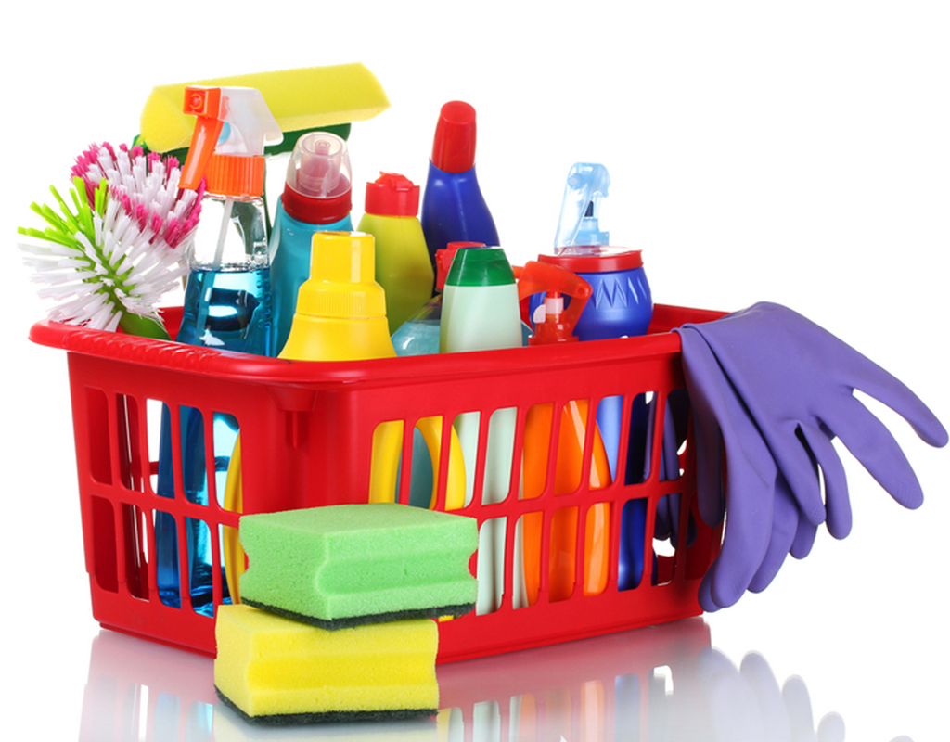](https://www.google.com/url?sa=i&url=https%3A%2F%2Fwww.ehmtic2014.com%2Fselect-best-cleaning-supplies%2F&psig=AOvVaw1i3SOFOpaS-8-hpGIE651m&ust=1596018526621000&source=images&cd=vfe&ved=0CAIQjRxqFwoTCPjgr8Pe7-oCFQAAAAAdAAAAABAD)

* Cleaning should progress from the least soiled (cleanest) to the most soiled (dirtiest) areas, and from the higher to lower levels so that debris may fall on the floor and is cleaned last in a systematic manner to avoid missing any areas.
* Cleaning equipment (e.g. buckets) should be well maintained.
* Equipment used for isolation areas for patients with COVID-19 should be colour-coded and separated from other equipment.
* Detergent or disinfectant solutions become contaminated during cleaning and progressively less effective if the organic load is too high; therefore, the continued use of the same solution may transfer the microorganisms to each subsequent surface. Thus, detergent and/or disinfectant solutions must be discarded after each use in areas with suspected/confirmed patients with COVID-19.
* It is recommended that fresh solution be prepared daily or for each cleaning shift.
* Buckets should be washed with detergent, rinsed, dried and stored inverted to drain fully when not in use.

**Products for environmental cleaning and disinfection**

* Follow the manufacturer’s instructions to ensure that disinfectants are prepared and handled safety, wearing the appropriate personal protective equipment (PPE) to avoid chemical exposure.
* The selection of disinfectants should take account of
* The microorganisms targeted,
* The recommended concentration and the contact time,
* The compatibility of the chemical disinfectants and surfaces to be tackled,
* Toxicity,
* Ease of use and stability of the product.

**Personal safety when preparing and using disinfectants**

[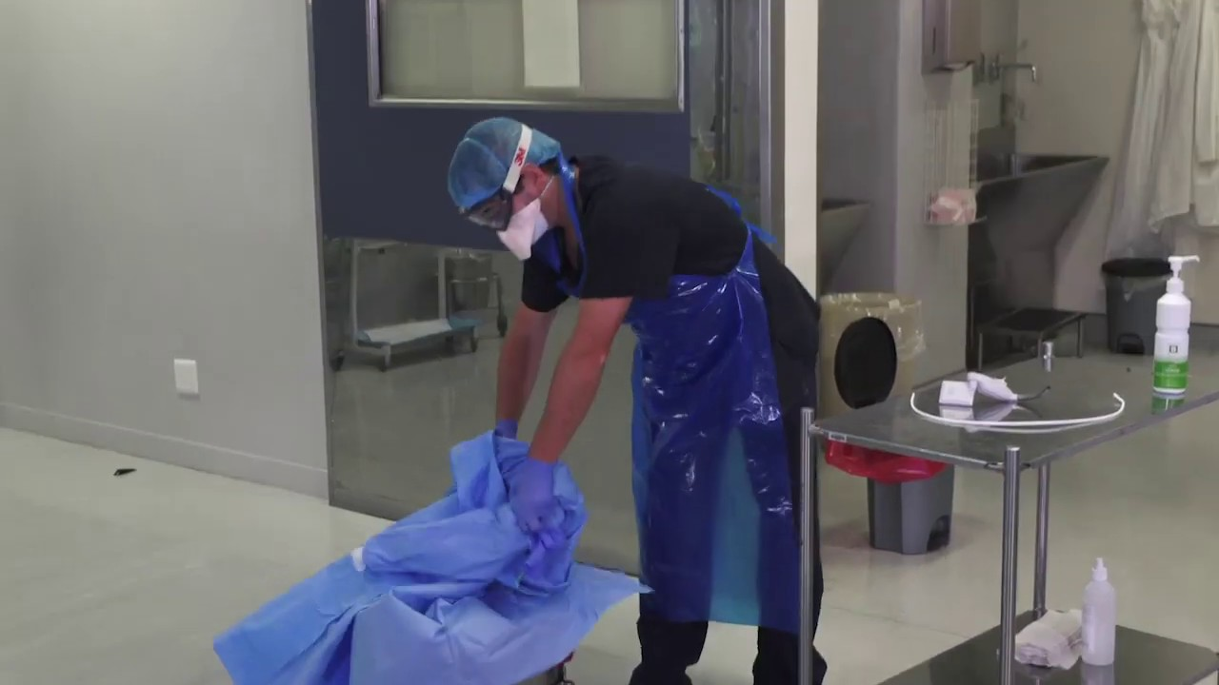](https://www.google.com/url?sa=i&url=https%3A%2F%2Fwww.youtube.com%2Fwatch%3Fv%3DvrrGyWSbEgI&psig=AOvVaw30iCqzbROC1UGLzL8BuHIV&ust=1596018439380000&source=images&cd=vfe&ved=0CAIQjRxqFwoTCMDQipfe7-oCFQAAAAAdAAAAABAJ)

* Cleaners should wear adequate personal protective equipment (PPE) and be trained to use it safely.
* When working in places where suspected or confirmed COVID-19 patients are present, cleaners should wear the following PPE: gown, heavy duty gloves, medical mask, eye protection (if risk of splash from organic material or chemicals), and boots or closed work shoes.
* Disinfectant solutions should always be prepared in well-ventilated areas.
* Avoid combining disinfectants, both during preparation and usage, as such mixtures cause respiratory irritation and can release potentially fatal gases, when combined with hypochlorite solutions.
* The disinfectant and its concentration should be carefully selected to avoid damaging surfaces and to avoid or minimize toxic effects on household members or users of public spaces.
* where disinfectants are being prepared and used, the minimum recommended PPE is rubber gloves, impermeable aprons, and closed shoes. Eye protection and medical masks may also be needed to protect against chemicals in use or if there is a risk of splashing.

**The use of chlorine-based products**

[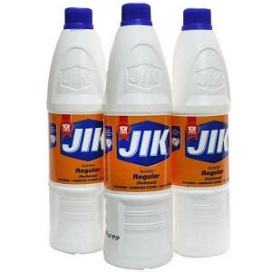](https://www.google.com/url?sa=i&url=https%3A%2F%2Fwww.2fumbe.com%2Fshop%2Fconsumables%2Fjik-bleach-detergent-750ml&psig=AOvVaw00DzgQKgtJwcuurwk0BNaM&ust=1593691322675000&source=images&cd=vfe&ved=0CAIQjRxqFwoTCOi0n5SBrOoCFQAAAAAdAAAAABAD)

Hypochlorite-based products include liquid (sodium hypochlorite), solid or powdered (calcium hypochlorite) formulations.

Hypochlorite is effective against several common pathogens at various concentrations.

Particular attention should be paid to environmental cleaning of high-touch surfaces and items. These include door and window handles, bathroom surfaces, toilets and taps, touchscreen personal devices, personal computer keyboards, and rest surfaces.

|  |
| --- |
| Regular household disinfectant containing 0.5% sodium hypochlorite (Chlorine bleach (3.8%); dilute 1 cup of bleach to 6 cups of water) should be applied.  OR  Regular household disinfectant containing 0.1% sodium hypochlorite should be applied. |

**How to clean**

* Daily clean and disinfect surfaces that are frequently touched in the room where the patient is being cared for, such as bedside tables, bedframes, and other bedroom furniture. Regular household soap or detergent should be used first for cleaning, and then, after rinsing, regular household disinfectant containing 0.1% sodium hypochlorite should be applied.
* Clean and disinfect bathroom and toilet surfaces at least once daily. Regular household soap or detergent should be used first for cleaning, and then, after rinsing, regular household disinfectant containing 0.1% sodium hypochlorite should be applied.
* Clean the patient’s clothes, bed linen, and bath and hand towels using regular laundry soap and water or machine wash at 60–90 °C (140–194 °F) with common household detergent, and dry thoroughly.
* Place contaminated linen into a laundry bag.
* Do not shake soiled laundry and avoid contaminated materials coming into contact with skin and clothes.
* Gloves and protective clothing (e.g. plastic aprons) should be used when cleaning surfaces or handling clothing or linen soiled with body fluids. Depending on the context, either utility or single-use gloves can be used. After use, utility gloves should be cleaned with soap and water and decontaminated with 0.1% sodium hypochlorite solution. Single-use gloves (e.g. nitrile or latex) should be discarded after each use.
* Perform hand hygiene before putting on and after removing gloves.
* Gloves, masks, and other waste generated during home care should be placed into a waste bin with a lid in the patient’s room before disposing of it as infectious waste.

Avoid other types of exposure to contaminated items from the patient’s immediate environment (e.g. do not share toothbrushes, cigarettes, eating utensils, dishes, drinks, towels, washcloths, or bed linen).



**Spraying disinfectants and other no-touch methods**

* In indoor spaces, routine application of disinfectants to environmental surfaces by spraying or fogging (also known as fumigation or misting) is not recommended for COVID-19. One study has shown that spraying as a primary disinfection strategy is ineffective in removing contaminants outside of direct spray zones. Moreover, spraying disinfectants can result in risks to the eyes, respiratory or skin irritation and the resulting health effects.
* Spraying or fogging of certain chemicals, may not be effective in removing organic material and may miss surfaces shielded by objects, folded fabrics or surfaces with intricate designs.
* If disinfectants are to be applied, this should be done with a cloth or wipe that has been soaked in disinfectant.

**Infectious Waste Disposal**

[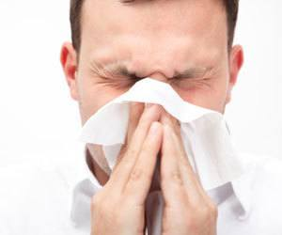](https://www.google.com/url?sa=i&url=http%3A%2F%2Fwww.howtocleanstuff.net%2Fhow-to-clean-dirt-from-your-nose%2F&psig=AOvVaw3aDOvRODDiPRkVT279jNq8&ust=1596018656578000&source=images&cd=vfe&ved=0CAIQjRxqFwoTCIC8xPze7-oCFQAAAAAdAAAAABAJ)

**Special measures are used to discard regulated waste.**

* This biohazardous e.g. used disposable tissue cannot be disposed of with your normal garbage
* This waste must be disposed in a separate specified container/bags. Unlike your normal trash bags, these biohazard bags must be equipped to handle potentially dangerous material.
* Place inside no-touch waste baskets (e. g foot operated bins) where they are easy to use e.g. inside the patient’s isolation room.
* Throw disposable items in the trash immediately after use.
* Wash your hands with soap and water after touching used tissues and similar waste.

**Disposal options:**

Drop- off collection sites-filled sharps containers are taken to a collection site. Hospital, clinics, health department are examples.

[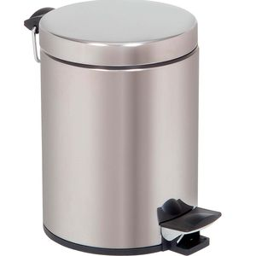](https://www.google.com/url?sa=i&url=https%3A%2F%2Fwww.medicalexpo.com%2Fmedical-manufacturer%2Ffoot-operated-waste-bin-48057.html&psig=AOvVaw2nWAWut9HmbtLtezJZialR&ust=1596017990163000&source=images&cd=vfe&ved=0CAIQjRxqFwoTCMDMzL_c7-oCFQAAAAAdAAAAABAD)

Image: Pedal operated bin

[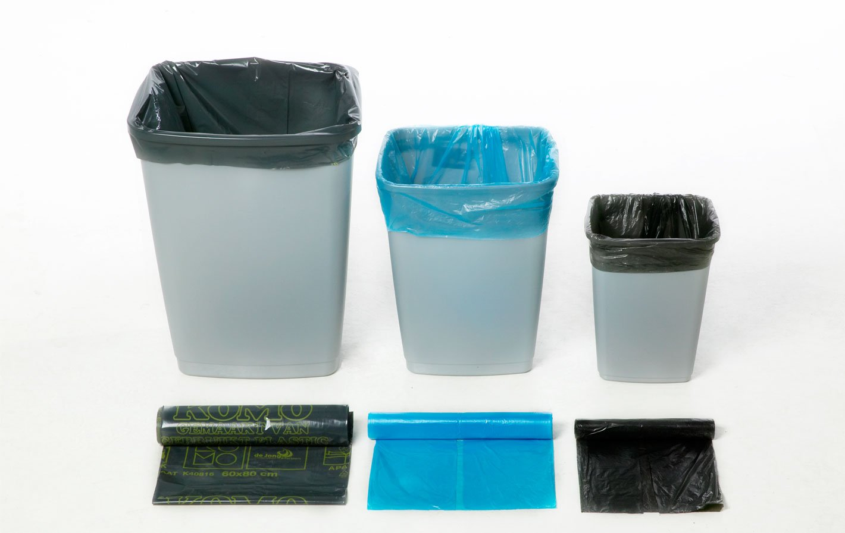](https://www.google.com/url?sa=i&url=http%3A%2F%2Fjavatradinguae.com%2Fproduct%2Fbin-liners%2F&psig=AOvVaw1MtTZlYg3jpuiVcUSAB2VY&ust=1596018755269000&source=images&cd=vfe&ved=0CAIQjRxqFwoTCIC5uKrf7-oCFQAAAAAdAAAAABAJ)

[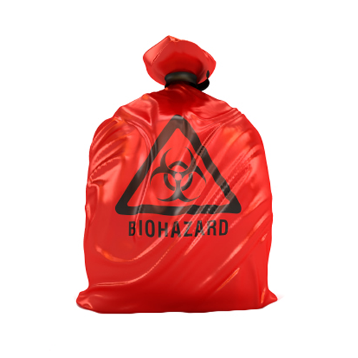](https://www.google.com/url?sa=i&url=https%3A%2F%2Fwww.indiamart.com%2Fproddetail%2Fred-biohazard-garbage-bag-11105475248.html&psig=AOvVaw3dno3bEowLPr6Zd1xgn64x&ust=1596018047543000&source=images&cd=vfe&ved=0CAIQjRxqFwoTCLDe3tjc7-oCFQAAAAAdAAAAABAI)

Image; Biohazard bag

<https://youtu.be/SYEk4b6uKcM>

**References**

1. World Health Organization. Home care for patients with Middle East respiratory syndrome coronavirus (MERS-CoV) infection presenting with mild symptoms and management of contacts: interim guidance (accessed 26 January 2020).

2. World Health Organization. Infection prevention and control of epidemic- and pandemic-prone acute respiratory diseases in health care. (accessed 26 January 2020).

3. World Health Organization. Clinical management of severe acute respiratory infection (SARI) when COVID- 19 disease is suspected. Geneva: World Health Organization; 2020 (accessed 17 March 2020).

4. World Health Organization. WHO guidelines on hand hygiene in health care: first global patient safety challenge. (accessed 20 January 2020).

5. World Health Organization. Global surveillance for human infection with novel coronavirus (2019-nCoV): interim guidance (accessed 17 March 2020).

6. Homebased isolation and care guidelines for patients with COVID-19- <https://www.health.go.ke/wp-content/uploads/2020/06/Home-Based-Isolation.pdf>